Table of Contents
Step 0 Intake + Interview Filing Status, Dependency 2
Step 1 Basic Information 3
Step 1a Filing Status 3
Step 1b Personal Information 3
Step 1c New Jersey Return 3
Step 1d Dependents or Qualifying Person(s) 3
Step 2 1099-R – Peter 4
Step 3 1099-R – Helen 5
Step 4 CSA 1099-R 6
Step 4a Form 1099-R 6
Step 4b Schedule A – Medical Deductions 6
Step 5 1099-R 7
Step 6 SSA-1099 – Peter 8
Step 7 K-1 9
Step 7a Schedule K-1 Form 1065 – Entity Information 9
Step 7b Schedule K-1 Form 1065 – Income 10
Step 7c Schedule K-1 Form 1065 – Credits 10
Step 7d Schedule K-1 Form 1065 – Deductions 10
Step 7e Interest Income 1099-INT 10
Step 8 Brokerage Statement Page 1 of 4 – 1099-INT 11
Step 8a Interest Income Screen 12
Step 8b Taxable State Interest Item Screen 12
Step 9 Brokerage Statement Page 2 of 4 – 1099-DIV 13
Step 9a Dividend Income Screen 14
Step 9b Taxable State Interest Item Screen 14
Step 9c 6251 14
Step 10 Capital loss carryover from prior year return 15
Step 11 Brokerage Statement Page 3 of 4 – 1099-B 15
Step 12 Brokerage Statement Page 4 of 4 – 1099-B 16
Step 13 W2-G 17
Step 14 Recoveries – NJ Tax Refund Worksheet 18
Step 14a State and Local Refunds 18
Step 14b Other Income Not Reported Elsewhere 18
Step 15 Notes – Itemized Deductions 19
Step 15a Notes – Deductions – Medical and Dental 19
Step 15b Notes – Deductions – Taxes You Paid 20
Step 15c Notes – Deductions – Mortgage Interest 21
Step 15d Notes – Deductions – Gifts to Charity 22
Step 16 Credit for the Elderly or the Disabled 23
Step 17 New Jersey Estimated payments 23
Step 17a Schedule A – Taxes You Paid 23
Step 17b Payments – State Estimated Payments 23
Step 18 ACA Health Insurance 24
Step 18a ACA Health Insurance – Health Insurance Section 25
Step 18b ACA Health Insurance – Add Sch A amount 25
State Section (New Jersey) 26
e-File Section 28

Step 0 Intake + Interview Filing Status, Dependency
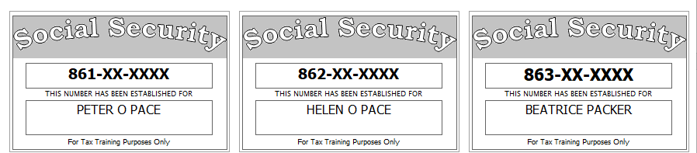
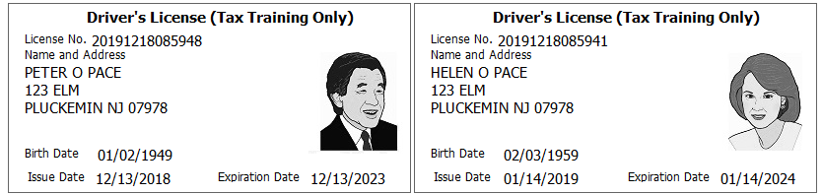
Before starting the return in TSO, you examine SS cards and picture id, review and correct the Intake Sheet, examine the prior year return, and examine and sort all tax documents. You also ask probing questions to determine dependency status and the appropriate filing status.
Information that normally would be discussed in the interview with the taxpayer and recorded on the intake sheet and/or NJ Checklist during the interview is instead given along with the step where the information is required. This is only done in the Scenario because a) you cannot actually do an interview, and b) to minimize your shuffling of papers while doing the problem.
Interview Notes:
As a result of a car accident several years ago, both Peter and Helen are totally and permanently disabled.
Peter is covered by Medicare. Helen has insurance through the ACA Marketplace.
Peter’s sister, Beatrice Packer, is totally and permanently disabled and relies upon her brother for her support. She receives $250 per month in social security benefits. She is covered by Medicare.
The Paces have owned their primary home in NJ for many years. They received a PTR refund and a Homestead Benefit payment. They also own a condo in Thackerville, OK (this is a second home, not an investment).
Notes from examination of prior year return:
- They did itemize last year
- They received tax refunds last year on their federal return and on their NJ return
- They have a capital loss carryforward
Extra interview information for New Jersey:
- The Paces want their contribution to the Gubernatorial Election Campaign Fund to be handled the same as their contribution to the Presidential Election Campaign Fund.
- Any NJ refund or amount owed should be handled the same as the Federal
- Peter is a veteran (he meets the requirements for the NJ Veteran Exemption)
Reference: 4012 Tab A, B, C
Tool: IRS Interactive Tax Assistant (link on Preparer page)
Tool: AARP Resource Tool for Counselors (Laminated Flow Chart)
Tool: TP4F Qualifying Child/Qualifying Relative Flowchart Tool (link on Preparer page)
Tool: Dependent Calculator (link on Preparer page)

Step 1 Basic Information
Enter Peter’s SSN to start the return

Step 1a Filing Status
Use the Filing Status you figured out as part of Step 0

Step 1b Personal Information
Use Intake Sheet and interview notes

Step 1c New Jersey Return
Answer “NO” to “Do you meet Property Tax Credit or Deduction Eligibility Requirements?” (even if you know that the requirements are met – we will deal with this later in the NJ section).
Answer “YES” to “Does the Taxpayer have Health Insurance?”.
Answer “YES” to “Does the Spouse have Health Insurance?”.
On the next screen, answer the Municipality question then Click “CONTINUE” before answering any other questions on this screen.
Tool: NJ Municipality Code Lookup Tool (link on Preparer page)
Tool: NJ 1040 Instructions – Municipality Code Table

Step 1d Dependents or Qualifying Person(s)
Enter information for dependents.
Hint: Do not go to the State Section and do anything until you are done with the Federal Section and Health Insurance sections. Use the NJ Checklist to record things you will need to remember when doing the State Section later.
Federal AGI: 0 Federal Refund: 0 NJ Refund: 0

Step 2 1099-R – Peter
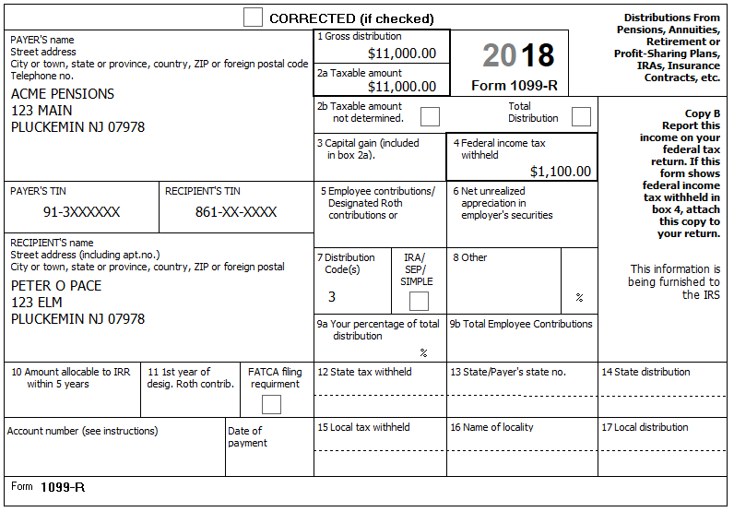
Federal AGI: 11,000 Federal Refund: 1,100 NJ Refund: 0
Q: What would change if Peter’s age were under 65, but over his company’s minimum retirement age (Fed & NJ)?

Step 3 1099-R – Helen
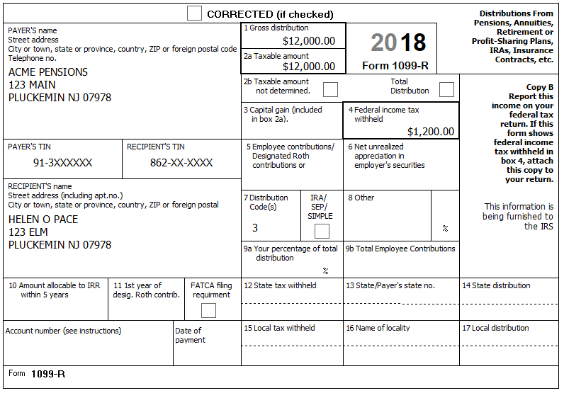
The minimum retirement age for the company Helen worked at is 62.
Hint: The dialog “We have some concerns with your Form 1099-R” is ok
NJ: Add to NJ Checklist (Adjustments to Line 20a)
Federal AGI: 23,000 Federal Refund: 5,761 NJ Refund: 1,281
Q: What would change if the minimum retirement age for the company Helen worked at were 58 (Fed & NJ)?
Q: Could Helen make an IRA contribution?

Step 4 CSA 1099-R
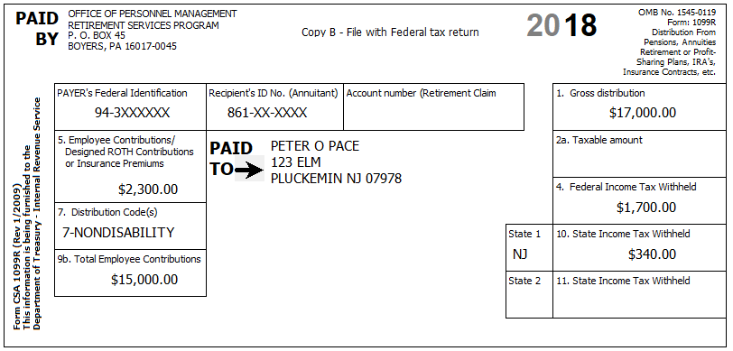
Peter started receiving this pension on February 1, 2014. Helen is also covered by the plan.
They confirm that the amount in Box 5 is for medical insurance.
Hint: The dialog “We have some concerns with your Form 1099-R” is ok
Tool: Annuity Calculator (link on Preparer page)
Hint: Use the Annuity Calculator to figure out the entries for the TSO Simplified Method worksheet
Q: If any previous year printout from this Annuity Calculator is included with the prior year return, do you need to Use the Annuity Calculator again for the current year?
NJ: Add untaxed portion (Box 1 – Box 2a) to NJ Checklist (Adjustments to Line 20b)

Step 4a Form 1099-R
Federal AGI: 39,500 Federal Refund: 4,113 NJ Refund: 723

Step 4b Schedule A – Medical Deductions
BP: Enter the insurance costs on Sch A now (to avoid forgetting to do so later)
Federal AGI: 39,500 Federal Refund: 4,113 NJ Refund: 723
Q: I would expect medical to flow to NJ and NJ refund to go up – why didn’t this happen?

Step 5 1099-R
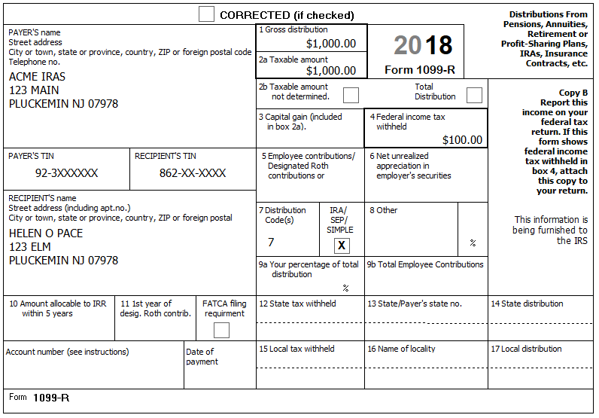
Federal AGI: 40,500 Federal Refund: 3,953 NJ Refund: 664
Q: Helen took this distribution in November – If she had taken it in June, then a) would the 1099-R be different? and b) would the federal and/or NJ refund change?

Step 6 SSA-1099 – Peter
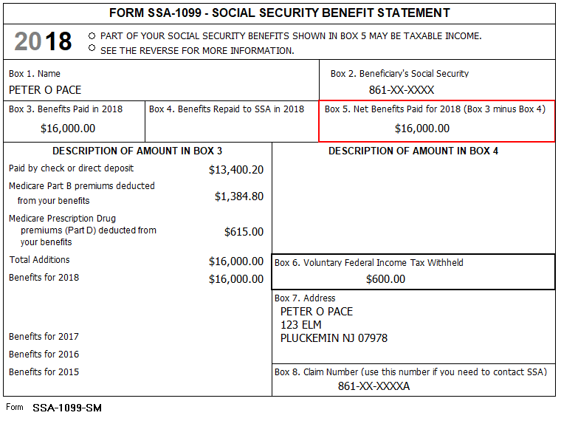
Federal AGI: 50,325 Federal Refund: 2,578 NJ Refund: 340
Q: SS was 16,000 – why did AGI go up by less than $10,000?

Step 7 K-1
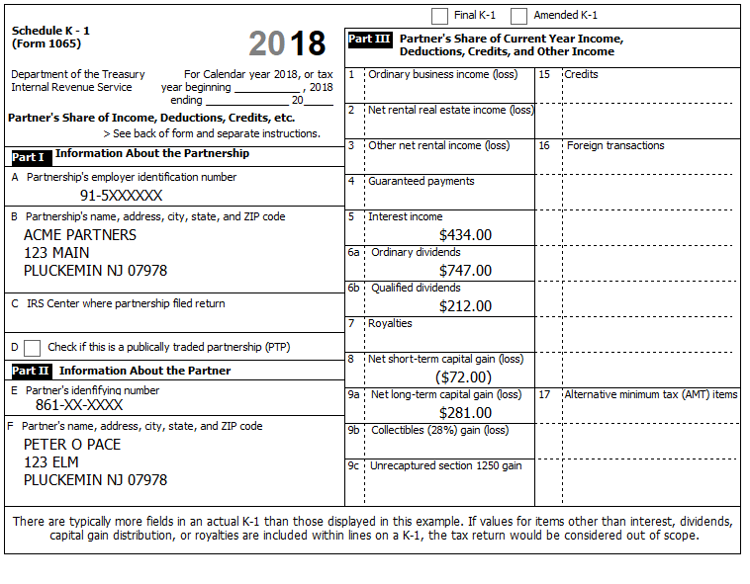
Select Schedule K-1 Form 1065
There are five sub-steps
Reference: 4012 D-47 to D-49

Step 7a Schedule K-1 Form 1065 – Entity Information
You determine that a) This is a Passive Entity, b) All Investment is At-Risk, c) The entire investment has not been disposed, d) This is not a PTP, and e) there is no Prior Year Unallowed Loss
Federal AGI: 50,325 Federal Refund: 2,578 NJ Refund: 340

Step 7b Schedule K-1 Form 1065 – Income
NOTE: As of 01-04-2019 there is a bug in TSO where it is not including amounts from K-1 box 5 (Interest Income) in NJ-1040, line 16a (Taxable Interest). Workaround: Do not enter box 5 amount on K-1 screen; enter box 5 amount as separate 1099-INT (We will do this in a later sub-step)
Federal AGI: 52,094 Federal Refund: 2,416 NJ Refund: 340

Step 7c Schedule K-1 Form 1065 – Credits
Nothing to do on this screen
Federal AGI: 52,094 Federal Refund: 2,416 NJ Refund: 340

Step 7d Schedule K-1 Form 1065 – Deductions
In addition to the above, Box 18a shows $33.00 of Tax-Exempt Interest Income. This amount is all from Tax-exempt Federal obligations
Federal AGI: 52,122 Federal Refund: 2,410 NJ Refund: 340
Check: Fed 1040, line 2a=33; 2b=0; 3a=212; 3b=747
Check: NJ-1040, line 16a=0; 16b=33; 17=747

Step 7e Interest Income 1099-INT
This is where we enter the amount from Box 5 of the K-1
Federal AGI: 52,925 Federal Refund: 2,314 NJ Refund: 340
Check: Fed 1040, line 2a=33; 2b=434; 3a=212; 3b=747
Check: NJ-1040, line 16a=434; 16b=33; 17=747
Q: We only added $434 of income – why did AGI go up by almost twice that amount?

Step 8 Brokerage Statement Page 1 of 4 – 1099-INT
Acme Brokerage | End of Year Tax Information Statement  Tax Year 2018 • Account 203040506 | Statement Date: 01-30-2019  Page 1 of 4 | 2018
123 Main  P.O. Box 07978-123  Pluckemin, NJ 07978  PAYER’S Federal ID No: 92-2XXXXXX | Peter O. Pace  123 Elm  Pluckemin, NJ 07978  RECIPIENT’S ID No: 821-XX-XXXX | Your Broker:  SERGE BRONSKI  888-555-5555  sbronski@acme.com

Interest Income – 1099-INT – Reported to IRS
1 | Interest Income (not included in line 3) | 1,500.00
2 | Early withdrawal penalty | 23.00
3 | Interest on US Savings Bonds & Treasury obligations | 2,500,00
4 | Federal Income tax withheld | 300.00
5 | Investment expenses | 0.00
6 | Foreign tax paid | 0.00
7 | Foreign country or US possession
8 | Tax-exempt interest (includes line 9) | 3,000.00
9 | Specified private activity bond interest (AMT) | 0.00
10 | Market discount | 105.00
11 | Bond premium | 116.00
12 | Bond premium on Treasury obligations | 127.00
13 | Bond premium on tax-exempt bond | 138.00
14 | Tax-exempt bond CUSIP numbers (see instructions)
15 | State
16 | State ID numbers
17 | State tax withheld | 0.00
 | FATCA filing requirement | NO

Interest Detail (only summary 1099-INT reported to IRS)
Date | 1 | 2 | 3 | 4 | 8 | 10 | 11 | 12 | 13
Safe Stuff
12-30-2018 | 1,500.00 | 23.00 | 2,500.00 | 300.00 | 0.00 | 105.00 | 116.00 | 127.00
New Jersey Muni Bond
12-30-2018 | 0.00 | 0.00 | 0.00 | 0.00 | 1,300.00 |  |  |  | 58.00
New York Muni Bond
12-30-2018 | 0.00 | 0.00 | 0.00 | 0.00 | 1,700.00 |  |  |  | 80.00
Totals: | 1,500.00 | 23.00 | 2,500.00 | 300.00 | 3000.00 | 105.00 | 116.00 | 127.00 | 138.00

The Savings Bond interest was not used for any tax-exempt purpose.

Step 8a Interest Income Screen
Hint: Boxes 10-13 are in scope for first time this year. (From 4012)
- Box 8: Enter paper Box 8 minus Box 13 amount into TSO box 8
- Box 10: Enter as-is; TSO automatically adds this to Box 1 for Sch B
- Box 11: Enter as-is; TSO automatically adds an adjustment to Sch B for this amount
- Box 12: Enter as-is; TSO automatically adds an adjustment to Sch B for this amount
- Box 13: Leave blank on TSO screen; enter paper Box 8 minus Box 13 amount into TSO box 8
Hint: NJ handling of Box 3 changes now that Box 12 is in scope. (From NJ Special Handling)
- Box labeled “Amount of Interest on U.S. Savings Bonds and Treasury Obligations that you want subtracted from your state return” – enter paper Box 3 minus Box 12 amount
Reference: 4012 D-9 to D-10 (be sure to use NTTC modified version)
Reference: NJ Special Handling (TY2019 version)
Federal AGI: 59,329 Federal Refund: 1,846 NJ Refund: 340
Check: Fed 1040, line 2a=2,895; 2b=4,296; 3a=212; 3b=747
Check: NJ-1040, line 16a=1,900; 16b=5,268; 17=747

Step 8b Taxable State Interest Item Screen
Federal AGI: 59,329 Federal Refund: 1,846 NJ Refund: 340
Check: Fed 1040, line 2a=2,895; 2b=4,296; 3a=212; 3b=747
Check: NJ-1040, line 16a=3,520; 16b=3,648; 17=747

Step 9 Brokerage Statement Page 2 of 4 – 1099-DIV
Acme Brokerage | End of Year Tax Information Statement  Tax Year 2018 • Account 203040506 | Statement Date: 01-30-2019  Page 2 of 4 | 2018
123 Main  P.O. Box 07978-123  Pluckemin, NJ 07978  PAYER’S Federal ID No: 92-2XXXXXX | Peter O. Pace  123 Elm  Pluckemin, NJ 07978  RECIPIENT’S ID No: 821-XX-XXXX | Your Broker:  SERGE BRONSKI  888-555-5555  sbronski@acme.com

Dividends and Distributions – 1099-DIV – Reported to IRS
1a | Total ordinary dividends (includes line 1b) | 300.00
1b | Qualified dividends | 200.00
2a | Total capital gain distributions (includes lines 2b, 2c, 2d) | 99.00
2b | Unrecaptured Section 1250 gain | 0.00
2c | Section 1202 gain | 0.00
2d | Collectibles (28%) gain | 0.00
3 | Nondividend distributions | 33.00
4 | Federal Income tax withheld | 80.00
5 | Section 199A dividends | 0.00
6 | Investment expenses | 0.00
7 | Foreign tax paid | 44.00
8 | Foreign country or US possession
9 | Cash liquidation distributions | 0.00
10 | Noncash liquidation distributions | 0.00
11 | Exempt-interest dividends (includes line 12) | 800.00
12 | Specified private activity bond interest dividends (AMT) | 8.00
13 | State
14 | State ID number
15 | State tax withheld | 0.00
 | FATCA filing requirement | NO

Dividend Detail (only summary 1099-DIV reported to IRS)
Date | 1a Ordinary dividends | 1b Qualified dividends | 2a Capital gains | 3 Nondiv. Dists. | 4 Federal w/h | 6 Foreign tax paid | 11 Exempt Interest | 12 Sp. PAB
Boring Mutual Fund (BMF)
12-30-2018 | 300.00 | 200.00 | 99.00 | 33.00 | 80.00 | 44.00 | 0.00 | 0.00
Select US Tax-Exempt Fund (SUSTE)
12-30-2018 | 0.00 | 0.00 | 0.00 | 0.00 | 0.00 | 0.00 | 300.00 | 0.00
Select NJ Qualified Fund (SNJQTE)
12-30-2018 | 0.00 | 0.00 | 0.00 | 0.00 | 0.00 | 0.00 | 500.00 | 8.00
Totals: | 300.00 | 200.00 | 99.00 | 33.00 | 80.00 | 44.00 | 800.00 | 8.00

Exempt-Interest Dividends by Area
Area | SUSTE | SNJQTE
Alabama | 1.3% | -
Alaska … Nevada | 28.2% | -
New Hampshire | 0.5% | -
New Jersey | 10.0% | 70.0%
New Mexico | 0.7% | -
New York … Wisconsin | 29.1% | 7.0%
Wyoming | 0.2% | -
District of Columbia | 0.2% | 1.0%
Puerto Rico | 9.7% | 2.0%
US Possessions | 20.1% | 20.0%
Total | 100.0% | 100.0%

Step 9a Dividend Income Screen
Hint: Be sure to look at Reference.
- Box 12: Leave blank on TSO screen; should be entered on form 6251
Reference: 4012 D-11 to D-12 (be sure to use NTTC modified version)
Federal AGI: 59,728 Federal Refund: 1,958 NJ Refund: 340
Check: Fed 1040, line 2a=3,695; 2b=4,296; 3a=412; 3b=1,047
Check: NJ-1040, line 16a=3,520; 16b=4,448; 17=1,047

Step 9b Taxable State Interest Item Screen
Federal AGI: 59,728 Federal Refund: 1,958 NJ Refund: 340
Check: Fed 1040, line 2a=3,695; 2b=4,296; 3a=412; 3b=1,047
Check: NJ-1040, line 16a=3,765; 16b=4,203; 17=1,047

Step 9c 6251
Hint: Search for “6251” or “AMT” to find 6251 entry screen
Q: When should you check if the return has Alternative Minimum Tax (AMT) (which would make the return out of scope)
Reference: 4012 D-12 (be sure to use NTTC modified version)
Federal AGI: 59,728 Federal Refund: 1,958 NJ Refund: 340

Step 10 Capital loss carryover from prior year return
Their prior year return showed that Peter had a long-term capital loss carryover of $12,345. There was no short-term capital loss carryover.
Federal AGI: 56,420 Federal Refund: 2,318 NJ Refund: 340
Check: Fed Sch D, line 7=-72; 15=-11,965

Step 11 Brokerage Statement Page 3 of 4 – 1099-B
Acme Brokerage | End of Year Tax Information Statement  Tax Year 2018 • Account 203040506 | Statement Date: 01-30-2019  Page 3 of 4 | 2018
123 Main  P.O. Box 07978-123  Pluckemin, NJ 07978  PAYER’S Federal ID No: 92-2XXXXXX | Peter O. Pace  123 Elm  Pluckemin, NJ 07978  RECIPIENT’S ID No: 821-XX-XXXX | Your Broker:  SERGE BRONSKI  888-555-5555  sbronski@acme.com

FORM 1099-B 2018 Proceeds from Broker and Barter Exchange Transactions
Long-term transactions for which basis is not reported to the IRS - Report on form 8949 with Box E checked
1a Description, 2 Long-term, 3 Basis not reported to IRS, 6 Net Proceeds
Quantity | 1b Date Acquired | 1c Date Sold | 1d Proceeds | 1e Cost or other Basis | 1f Code | 1g Adj | Gain / Loss(-) | 4 Federal Tax Withheld
Acme Corp (ZACO)
50.000 | 09-01-1996 | 05-10-2018 | 4,000.00 | 3,000.00 |  |  | 1,000.00 | 0.00
100.000 | 09-01-1996 | 10-20-2018 | 7,500.00 | 6,000.00 |  |  | 1,500.00 | 0.00
150.000 |  |  | 11,500.00 | 9,000.00 |  | 0.00 | 2,500.00 | 0.00
Acme Inc (ZAI)
65.000 | ** | 10-20-2018 | 5,555.00 | ** | W | 197.00 | ** | 0.00
Totals |  |  | 17,055.00 |  |  |  |  | 0.00
** Information not available

Acme Brokerage does not have a record for the purchase of ZAI stock. Peter inherited the 65 shares from his uncle who paid $6,500 for the shares on 10/15/2008. The stock was worth $7,222 on 08/29/2018, the day his uncle died.
Federal AGI: 56,420 Federal Refund: 2,318 NJ Refund: 340
Check: Fed Sch D, line 7=-72; 15=-10,935
Q: Why did the Federal AGI and Refund not change?
Reference: 4012 D-23 to D-25

Step 12 Brokerage Statement Page 4 of 4 – 1099-B
Acme Brokerage | End of Year Tax Information Statement  Tax Year 2018 • Account 203040506 | Statement Date: 01-30-2019  Page 4 of 4 | 2018
123 Main  P.O. Box 07978-123  Pluckemin, NJ 07978  PAYER’S Federal ID No: 92-2XXXXXX | Peter O. Pace  123 Elm  Pluckemin, NJ 07978  RECIPIENT’S ID No: 821-XX-XXXX | Your Broker:  SERGE BRONSKI  888-555-5555  sbronski@acme.com

FORM 1099-B 2018 Proceeds from Broker and Barter Exchange Transactions
Long-term transactions for which basis is reported to the IRS - Report on form 8949 with Box D checked
1a Description, 2 Long-term, 3 Basis reported to IRS, 6 Net Proceeds
Quantity | 1b Date Acquired | 1c Date Sold | 1d Proceeds | 1e Cost or other Basis | 1f Code | 1g Adj | Gain / Loss(-) | 4 Federal Tax Withheld
Acme Corp (ZACO)
10.000 | 07-02-2004 | 01-15-2018 | 450.00 | 440.00 |  |  | 10.00 | 0.00
10.000 | 07-02-2004 | 02-15-2018 | 440.00 | 440.00 |  |  | 0.00 | 0.00
10.000 | 07-02-2005 | 03-15-2018 | 450.00 | 420.00 |  |  | 30.00 | 0.00
10.000 | 07-02-2005 | 04-15-2018 | 440.00 | 420.00 |  |  | 20.00 | 0.00
10.000 | 07-02-2005 | 05-15-2018 | 450.00 | 420.00 |  |  | 30.00 | 0.00
10.000 | 07-02-2005 | 06-15-2018 | 440.00 | 420.00 |  |  | 20.00 | 0.00
10.000 | 07-02-2005 | 07-15-2018 | 450.00 | 420.00 |  |  | 30.00 | 0.00
10.000 | 07-02-2005 | 08-15-2018 | 440.00 | 420.00 |  |  | 20.00 | 0.00
10.000 | 07-02-2005 | 09-15-2018 | 450.00 | 420.00 |  |  | 30.00 | 0.00
10.000 | 07-02-2005 | 10-15-2018 | 440.00 | 420.00 |  |  | 20.00 | 0.00
10.000 | 07-02-2005 | 11-15-2018 | 450.00 | 420.00 |  |  | 30.00 | 0.00
10.000 | 07-02-2005 | 12-15-2018 | 440.00 | 420.00 |  |  | 20.00 | 0.00
120.000 |  |  | 5,340.00 | 5,080.00 |  | 0.00 | 260.00 | 0.00
Acme Inc (ZAI)
30.000 | 07-02-2007 | 03-15-2018 | 430.00 | 400.00 |  |  | 30.00 | 0.00
30.000 | 07-02-2007 | 06-15-2018 | 430.00 | 400.00 |  |  | 30.00 | 0.00
30.000 | 07-02-2008 | 09-15-2018 | 430.00 | 440.00 |  |  | -10.00 | 0.00
30.000 | 07-02-2008 | 12-15-2018 | 430.00 | 440.00 |  |  | -10.00 | 0.00
120.000 |  |  | 1.720.00 | 1,680.00 |  | 0.00 | 40.00 | 0.00
Acme Ltd (ZALTD)
30.000 | 07-02-2007 | 03-15-2018 | 3,110.00 | 700.00 |  |  | 2,410.00 | 0.00
30.000 | 07-02-2007 | 06-15-2018 | 3,120.00 | 700.00 |  |  | 2,420.00 | 0.00
30.000 | 08-03-2008 | 09-15-2018 | 3,130.00 | 820.00 |  |  | 2,410.00 | 0.00
30.000 | 08-03-2008 | 12-15-2018 | 3,140.00 | 820.00 |  |  | 2,420.00 | 0.00
120.000 |  |  | 12,500.00 | 3,040.00 |  | 0.00 | 9,460.00 | 0.00
Totals |  |  | 19,560.00 | 9,800.00 |  | 0.00 | 9,760.00 | 0.00

Federal AGI: 58,173 Federal Refund: 2,108 NJ Refund: 340
Check: Fed Sch D, line 7=-72; 15=-1,175
Reference: 4012 D-23 to D-25 (esp p. D-25)

Step 13 W2-G
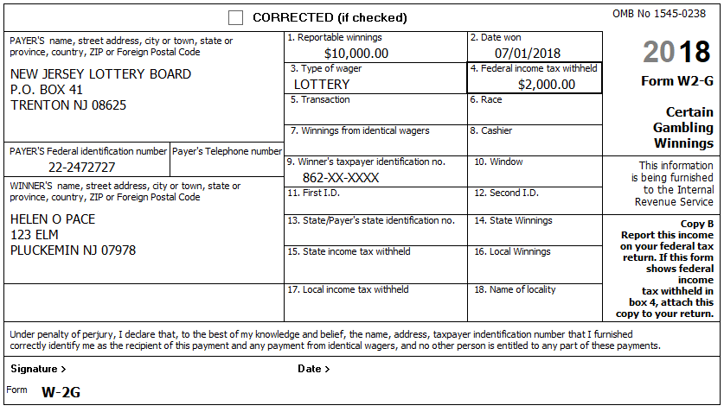
Helen had losses of $5,000 on slots and $4,000 on lottery tickets. (with documentation)
Q: If Helen had 3 separate lottery wins, each for $10,000, how would the Fed and NJ taxability of her winnings change?
Reference: 4012 D-49
NJ: Record on NJ Checklist (NJ Line 24 – Gambling Winnings)
Federal AGI: 68,173 Federal Refund: 2,908 NJ Refund: 340

Step 14 Recoveries – NJ Tax Refund Worksheet
The Paces received several tax refunds. You explain that these might be recoveries that need to be included as income on the current year return:
544 | Federal prior year income tax refund
203 | NJ prior year income tax refund
1,200 | PTR refund for prior year
 | They did itemize in prior year
400 | Homestead benefit refund for prop taxes paid three years ago (when they also itemized)

In order to calculate the taxable amount of these refunds, you need information from their prior year return (which you have access to):
1,245 | State and local taxes (Sch A, line 5)
 | Sch A, box 5a is checked (they elected income tax instead of sales tax)
1,135 | Sales Tax amount (no need to use NJ Sales Tax calculator)
9,000 | Real estate taxes (Sch A, line 6)
14,500 | Total itemized deductions (Sch A, line 29)
1 | Taxable income (1040, line 43)

Hint: Use the NJ Tax Refund Worksheet to calculate the taxable amounts for the above (be sure to select 2018 as the Current Year)
Hint: The prior year (2017) and the current year (2018) use different line numbers for state and local taxes – this can be confusing
Reference: New Jersey Special Handling
Tool: NJ Tax Refund Worksheet (link on Preparer page under NJ Preparer Tools)
Q: How are the (rather strange) numbers for taxable amounts calculated?

Step 14a State and Local Refunds
Hint: Just enter the amount from the NJ Tax Refund Worksheet in the box labelled “Bypass State Refund Worksheet” and ignore the rest of the screen
Federal AGI: 68,219 Federal Refund: 2,902 NJ Refund: 340

Step 14b Other Income Not Reported Elsewhere
Hint: You can make separate entries for PTR & HB
Hint: “Form belongs to” is required, but no “joint” option – pick Peter
NJ: The federal Other Income recovery amounts should be included on the NJ Checklist (Adjustments to Line 26)
Federal AGI: 69,123 Federal Refund: 2,794 NJ Refund: 340

Step 15 Notes – Itemized Deductions
Check: Before beginning this step, Use Compare Deductions to check that Itemized Deductions = 9,340 (equals: 340 (Line 7) + 9,000 (Line 16))
Hint: Some items in the following sub-Steps may not be deductible or may have already been entered – be alert…

Step 15a Notes – Deductions – Medical and Dental
Medicare – Part B $1,385
Medicare – Part D $615
Insurance paid by Office of Personnel Management $2,300
Insurance policy from HealthCare.gov $6,360
Doctor co-pays and deductibles $300
Long Term Care (LTC) insurance (Helen) $1,800
Reference: 4012 F-5 to F-6
Hint: LTC is subject to special rules and should only be entered using LTC sub-screen
Hint: The appropriate deduction amount for Marketplace (HealthCare.gov) policies can only be calculated after form 8962 has been completed – do NOT enter now – we will do this later.
Federal AGI: 69,123 Federal Refund: 2,794 NJ Refund: 340
Check: After this step, Itemized Deductions = 10,316

Step 15b Notes – Deductions – Taxes You Paid
Principal residence in NJ:
- The Paces received an escrow reconciliation statement from their lender showing $6,300 was paid in the current calendar year from escrow for property taxes.
- They received a total Homestead Benefit in current year of $400 applied (in two parts) to their quarterly property tax bills. You verified this amount using the NJ Tool
- Info from their prior year PTR booklet:
  - Gross property tax was $6,850
  - Their PTR base year amount is $5,650
  - They received a PTR refund of $1,200.
  - Block: 50001, Lot: 00002, Qualifier: blank
  - Single-family house, ownership is not shared
- Info from TP / Property Tax lookup
  - Senior Citizen deduction of $250 (both prior year & current year)
Condo in Thackerville, OK:
- The Paces received a document from the Thackerville local real estate tax authority showing $2,450 in real estate taxes were paid in the current calendar year.
They also owed $42 from their NJ return from three years ago, which they paid on 06-15-2018.
Reference: 4012 F-6
BP: You must click “Add Sales Tax Worksheet” and enter State, Zip, and Number of days (but not percents) even if you do not have any extra sales tax on cars, etc.
Tool: NJ Inquiry for Homestead Benefit (link on Preparer page under NJ)
Tool: Property Tax lookup tools (links on Preparer page under NJ)
NJ: Record appropriate Real estate tax and BLQ info on NJ Checklist (Property Tax)
Federal AGI: 69,123 Federal Refund: 2,794 NJ Refund: 340
Check: After this step, Itemized Deductions = 19,976
Q: Can you fill in the missing values in the following table?
Description | 2017 | 2018
Gross Property Tax | 6,850
Deductions | 250 | 250
Net Property Tax
Homestead Benefit | 375 | 400
Check or Escrow amount |  | 6,300
PTR Base year amount | 5,650 | 5,650
PTR Refund | 1,200
OK Condo tax |  | 2,450
Sch A Property Tax | 9,000

Q: If all other numbers stayed the same except, they didn’t get Senior Citizen deduction in current year, would that affect their PTR refund?
Q: How much deduction (if any) did they lose due to the SALT limitation?

Step 15c Notes – Deductions – Mortgage Interest
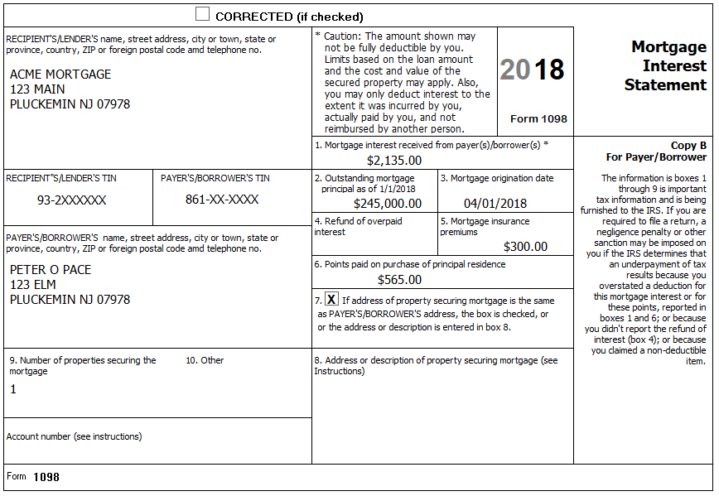
The above 1098 is for a Home Equity loan the Paces took out on their NJ home. The entire proceeds were used to make major improvements to accommodate their disabilities and expand space.
The Paces received a second Form 1098 from Acme Bank related to their Home Equity Line of Credit on the Thackerville, OK condo. The principal amount of $11,000 was all used for gambling debts.
Interest $777
Oddity: The first choice on the Schedule A Interest screen is “Home Mortgage Loan(s) used to Buy/Build/Improve Home”. If you click it, you’ll see there is one question: “Did you use all of your home mortgage loan(s) to buy, build or improve your home? (Yes / No)”. Answering either “Yes” or “No” doesn’t seem to do anything…?
Reference: 4012 F-9
Federal AGI: 69,123 Federal Refund: 2,794 NJ Refund: 340
Check: After this step, Itemized Deductions = 22,676
Q: Would deductibility change if the NJ loan was for gambling debts and the OK loan was for improvements?
Q: If their assessed value goes up due to improvements, will their PTR base amount change?

Step 15d Notes – Deductions – Gifts to Charity
Church cash donations with church generated listing $520
Canceled check for contribution to the Most Worshipful Sons Of Solomon Grand Lodge Of Oklahoma $80
Cash donations to Santa ringing bell outside local grocery store (no records) $20
Donation to a political campaign $50
Reference: 4012 F-10
Tool: IRS Exempt Organization Search (link on Preparer page)
Hint: Use the Exempt Organization Search tool to check if donations to the Most Worshipful Sons Of Solomon Grand Lodge Of Oklahoma are tax-exempt. (Just enter Thackerville in the City search field.) [It is listed as included in Pub 78 – so donations are tax-deductible.]
Hint: If you use the Override option for Cash, then all you need to enter is the total (no names, dates, etc.) – Just be sure to document (e.g. with ScratchPad) in the TP’s paper file how you arrived at the total.
Federal AGI: 69,123 Federal Refund: 2,794 NJ Refund: 340
Check: After this step, Itemized Deductions = 23,276

Step 16 Credit for the Elderly or the Disabled
TaxSlayer does not automatically check eligibility for the Credit for the Elderly or the Disabled (Schedule R); the preparer must use the chart on page G-17 of Pub. 4012 to manually determine potential eligibility. If potentially eligible, then the preparer must provide the information necessary to calculate official eligibility and the amount of the credit, if any.
Reference: 4012 G-17 to G-19
Federal AGI: 69,123 Federal Refund: 2,794 NJ Refund: 340
Q: Is TP eligible for this Credit? If not, why not?

Step 17 New Jersey Estimated payments
They made the following NJ estimated payments:
Tax Year | TY2017 | TY2018 | TY2018 | TY2018 | TY2018
Date | 01-03-2018 | 04-14-2018 | 06-15-2018 | 09-11-2018 | 01-14-2019
Amount | $50.00 | $60.00 | $60.00 | $60.00 | $70.00

Step 17a Schedule A – Taxes You Paid
Federal AGI: 69,123 Federal Refund: 2,794 NJ Refund: 340
Q: Nothing changes on Sch A as a result of this entry - why?

Step 17b Payments – State Estimated Payments
Federal AGI: 69,123 Federal Refund: 2,794 NJ Refund: 590

Step 18 ACA Health Insurance
Peter had Medicare all year.
Helen had a Marketplace (HealthCare.gov) policy all year.
Beatrice had Medicare all year.
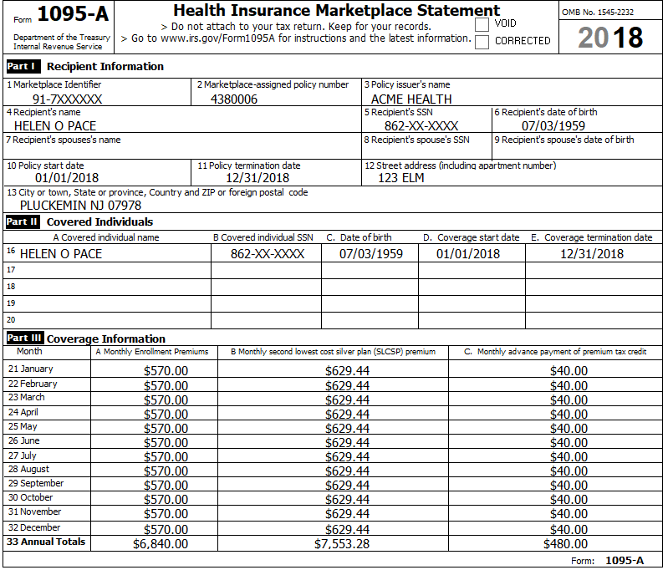
Reference: 4012 Tab H

Step 18a ACA Health Insurance – Health Insurance Section
Federal AGI: 69,123 Federal Refund: 2,676 NJ Refund: 590

Step 18b ACA Health Insurance – Add Sch A amount
Hint: To calculate the correct amount for Sch. A, you need to look at a couple of lines on the 1040 after completing the Health Insurance section in TSO. Use the following procedure:
- Calculate the “TY Net Premium” by subtracting the 1095-A, Column C total from the Column A total. (e.g. 6,840 – 480 = 6,360)
- Calculate the “Sch A Deduction Amount”:
  - If Sch 2, Line 46 (Excess advance premium tax credit repayment) has a value, add it to the “TY Net Premium” (e.g. 6,360 + 118 = 6,478)
  - If Sch 5, Line 70 (Net premium tax credit) has a value, subtract it from the “TY Net Premium”.
- Enter the “Sch A Deduction Amount” on the Medical Deductions screen in TSO. If there is already an amount in the Medical and dental insurance box, then the “Sch A Deduction Amount” to the existing amount. (e.g. 2,300 + 6,478 = 8,778)
BP: Be sure to document the calculation of the amount you end up entering into TSO for your Quality Reviewer and for the TP records.
Federal AGI: 69,123 Federal Refund: 3,210 NJ Refund: 590
Check: After this step, Itemized Deductions = 29,754

State Section (New Jersey)
You have collected information during several Federal Steps on your NJ Checklist – It is now time to enter that information into TSO
Step 19a NJ Checklist – Basic Information
Check: NJ-1040, line 13: Before: $4,500; After: $9,500
Federal AGI: 69,123 Federal Refund: 3,210 NJ Refund: 590
Step 19b NJ Checklist – Income Subject to Tax
Check: NJ-1040, line 20a: Before: $40,500; After: $28,500
Check: NJ-1040, line 20b: Before: $0; After: $500
Check: NJ-1040, line 24: Before: $0; After: $0
Check: NJ-1040, line 26: Before: $904; After: $0
Federal AGI: 69,123 Federal Refund: 3,210 NJ Refund: 590
Step 19c NJ Checklist – Subtractions from Income
Federal AGI: 69,123 Federal Refund: 3,210 NJ Refund: 590
Step 19d NJ Checklist – Credits
On the NJ Property Tax Credit Deduction screen there is a question: “Are you eligible and file for a homestead benefit application to receive the property tax credit with the homestead benefit?” – Answer “Yes”
Check: NJ-1040, line 38a: Before: $0; After: $5,650
Check: NJ-1040, line 38b Block: Before: Blank; After: Blank (should be 50001)
Check: NJ-1040, line 38b Lot: Before: Blank; After: Blank (should be 00002)
Check: NJ-1040, line 38c Block: Before: Blank; After: 1801
Check: NJ-1040, line 54: Before: $0; After: $0
Federal AGI: 69,123 Federal Refund: 3,210 NJ Refund: 590
Step 19e NJ Checklist – Tax
The Paces did not make any purchases which would be subject to Use Tax.
Federal AGI: 69,123 Federal Refund: 3,210 NJ Refund: 590
Step 19f NJ Checklist – Payments
Federal AGI: 69,123 Federal Refund: 3,210 NJ Refund: 590
Step 19g NJ Checklist – Miscellaneous Forms
Federal AGI: 69,123 Federal Refund: 3,210 NJ Refund: 590

e-File Section
Collect any final information necessary…
You will get a warning that reads: “You have entered Form 1099R for IRA and Pension Distributions. The amount of taxable distribution plus any rollover amounts are less than the gross distribution entered. If this is an annuitized distribution, please continue with the E-file process….” – This is ok (refers to CSA 1099-R where we used simplified general rule).
Correct any other issues before proceeding then click “CONTINUE”.
Step 20a E-File – Return Type
The Paces have a Federal refund – they do not want direct deposit (per the Intake Sheet)
Hint: Federal Return Type = “E-file: Paper Check”
Step 20b E-File – Tax Preparation and E-File Information
The Paces did not supply an email on the Intake Sheet
Step 20c E-File – State Return(s)
The Paces have a NJ refund – the do not want direct deposit (per Interview)
Hint: NJ Return Type = “E-file: Paper Check”
Step 20d E-File – Third Party Designee Info
Hint: Do NOT fill in anything here.
Step 20e E-File – Consent to Disclose Tax Return Information …
Trevor agrees to GRANT consent.
Enter any 5 digit Primary and Secondary PIN and Date.
Step 20f E-File – Questions
Answer questions based on Intake Sheet.
“Was the taxpayer physically present during the entire return preparation and quality review process?” – answer “YES”

Step 20g E-File – State ID (Optional)
Ignore this section
Hint: Click Save when done
Step 20h E-File – Submission
You can ignore red message: “The IRS is no longer accepting e-files at this time.”
BP: Follow District / Site rules for what, if anything, you should do on this screen.

